PROJECT DESIGN PHASE
SOLUTION ARCHITECTURE
Date
Team ID | SWTID-2026-3317 _______________
Project Name | AI FAQ Assistant
Maximum Marks | 4 Marks

Solution Architecture
The solution architecture describes how the components of the AI FAQ Assistant work together to provide authentication, FAQ management, AI-based query processing, database storage and responses.
Architecture Components
- User Interface: Allows users to enter questions and view answers.
- Backend API: Handles requests, business logic, authentication and communication between components.
- JWT Authentication: Provides secure user and admin login sessions.
- MongoDB FAQ Database: Stores FAQ questions, answers, user information and related records.
- AI Service: Processes natural-language questions and helps generate relevant responses.
- Admin Module: Allows authorized administrators to add, update and delete FAQ information.

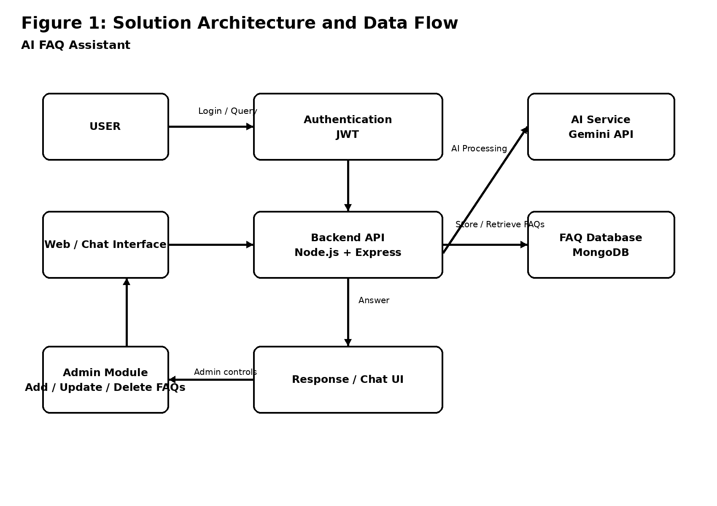
Figure 1: Solution Architecture and Data Flow of the AI FAQ Assistant
Data Flow
1. The user opens the web/chat interface and enters a question.
2. The request is sent to the backend API.
3. The backend validates the request and user authentication when required.
4. The backend retrieves relevant FAQ information from MongoDB.
5. The AI service processes the natural-language query and available information to produce a relevant response.
6. The backend sends the response back to the interface.
7. The user views the answer in the chat interface.
8. Authorized administrators can add, update or delete FAQ information through the admin module.
Technology Stack: Frontend – HTML/CSS/JavaScript; Backend – Node.js and Express; Database – MongoDB; Authentication – JWT; AI – Gemini API.

